**Phrasal Verbs about Pandemics**





**Be aware that many of these phrasal verbs also have other meanings.**



**Phrasal verbs often include another preposition if they take an object.**

**Phrasal Verb Mix and Match**

*Connect each of the phrasal verbs below with the correct definition.*

1) air out a) to endure adversity (in good spirits)

2) bear up b) to start showing symptoms of an illness

3) break out c) to be confined in a small area

4) call off d) to ventilate, to open doors and windows to refresh a room

5) catch out e) for time to move very slowly

6) come down with f) to cancel

7) coop up g) for an epidemic or pandemic to begin

8) do without h) to become depressed or sad

9) drag on i) to not go near, maintain a distance

10) fit out (with) j) to take by surprise while unprepared

11) get down k) to consume all of something

12) keep away (from) l) to survive or manage despite a lack of something

13) lay off m) to recover from something bad and survive

14) lead astray n) to equip

15) listen up o) to confine people to one place

16) lock down p) to convince people to believe something that isn’t not true

17) pull through q) to pay attention

18) run out (of) r) to dismiss people from their jobs for economic reasons

Text here

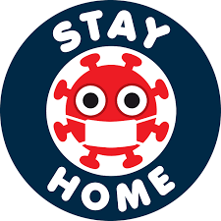

**Phrasal Verbs about Pandemics**



**air out bear up break out call off catch out come down with coop up do without drag on fit out get down keep away lay off lead astray listen up lock down pull through run out**

Insert the phrasal verbs that fit best into the gaps in the sentences below.

You will need to conjugate them appropriately.

**1)** The government has asked people to **________ _______** from each other during the state of emergency and maintain a distance of at least 2 metres.

**2)** The government has decided to **________** the country **______**and confine everybody to their homes.

**3)** Many countries have been **________ _______** and were not prepared for a virus that was so contagious.

**4)** We need to do something entertaining and fun to stop us from **________ _______** or going completely stir crazy after being in the same place for more than a month.

**5)** There isn’t any more wine. Oh well! We will have to **________ _______** until it’s time to go shopping again.

**6)** My wife is a doctor and she told me households that have large families should open windows and **________ _______** all the rooms in the morning in case somebody has a cold or virus.

**7)** We were very frightened when my father caught the virus but were so relieved when he **________ _______** and made a complete recovery.

**8)** After the second week of quarantine, the days really seemed to **________ _______**. Thankfully, I had lots of books to read and plenty of TV shows to catch up on.

**9)** There are 9 people all **________ _______** together in the flat over the road from us. I don’t know how they can cope with each other for so long in such a small space.

**10)** I need to go to the supermarket because we have **________ _______** of wine.

**11)** The country needs to **________ _______** and take note of what the scientists and medical professionals are saying during the pandemic.

**12)** There needs to be some kind of law against people who post fake news about the virus online to **_________** people **________**. This kind of activity could cost lives.

**13)** The disease first **________ _______** in China before it spread to the rest of the world.

**14)** My wife is a doctor and had to self-isolate when she started to **________ ________ _______** symptoms of the virus which she could have caught from her patients.

**15)** When the government announced the emergency measures, my company had to **________ _______** the majority of the workers. It has promised to give everybody their jobs back when the quarantine has finished.

**16)** The leading medical officer in the country has demanded that the country’s hospitals be **________ _______** with ventilators and the appropriate protective clothing and equipment.

**17)** We had to **________ _______** our holiday in the UK when the outbreak first started.

**18)** The family has been confined to their home for nearly 6 weeks now but they are **________ _______** pretty well. In fact, they seem to be quite happy.



Text here

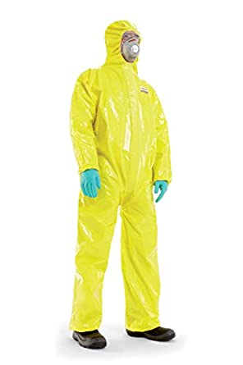

**Life in Quarantine**

Insert the phrasal verbs that fit best into the gaps in the story below.

You will need to conjugate the verbs appropriately.



**air out bear up break out call off catch out come down with coop up do without drag on fit out get down keep away lay off lead astray listen up lock down pull through run out**

Ever since the government **_________ _______** this country and told everybody to stay at home, unless shopping for essential groceries or going to work at key jobs, the general public has surprised itself, and the powers that be, by showing an almost complete willingness to comply with the emergency laws. What is more, the majority of the public seem to be **_________ _______** pretty cheerfully despite what psychologists have deemed to be very stressful conditions. Many people crowd onto balconies at 8pm every night to applaud key workers and to show their appreciation of the people and services that society clearly cannot **_________ _______**.

This spirit of community has surprised and even shocked some. There has been some anger, particularly from those workers who were **_________ _______**at the beginning of the emergency, but the overall attitude has been one of cooperation. Leading mental health experts were expecting the conditions to **_________** people **________**, and there have been cases of severe depression but nowhere near the numbers expected. Large households have shown extraordinary resilience despite people being **_________ _______** for so long in such close proximity to each other.

The few times that the general public have been forced to come out and mix with each other have also demonstrated remarkable self-discipline. When households **_________ _______** of essential supplies, only one resident is sent to the supermarket to buy the provisions. When queuing in the supermarket lines, everybody seems to observe social distancing rules and **_________** two metres **__________** from each other. Very few seem to have been **_________ _______** by ridiculous conspiracy theories despite there being a plethora of them on social media.

When the epidemic first **_________ _______** in this country, it is true that many did not really take the threat too seriously and were not really prepared. The authorities and the health service were **_________ _______** badly, and it looked as if the resources and infrastructure would be overwhelmed by the speed and intensity of the contagion. Politicians did not appear to **_________ _______** and take heed of the advice being offered by WHO and other health organisations, at first. But then it hit home. Everybody seemed to get what was happening all at once.

However, there is one aspect of all this that is really starting to cause problems, boredom. To many of us, the days seem to just **_________ _______**, with one day seeming pretty much like any other. So many events have been **_________ _______**, and being restricted to the home does not give people many options for enjoyment. Opening a window to **_________ _______**a room is the only contact some people have with the outside world aside from taking out the rubbish or shopping. But although all of this is mind-numbingly boring, let us not forget just why the quarantine exists in the first place.

Many people who have **_________ _______ ________** the virus have said that it was truly awful and one of the worst illnesses they have ever experienced. Some feared that they would not **_________ _______** and, indeed, many have died as a result of this disease. Thankfully, hospitals have been **_________ _______** with specialist equipment and are in a better position than they would be in a lot of other countries to deal with the emergency. So, for the meantime, the best thing anybody can do to help their community and their country is to stay home.

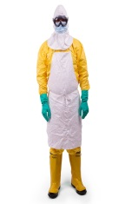



**Quarantine Rules and Morale Debate**

You live in a tower block in a city in East Anglia, England. There is a quarantine in place because of a viral outbreak in your region. There has been some argument about the implementation of some of the rules in the tower block that you live in. Read the memo below and then read your personality card. After that, attend the online meeting and debate what the committee should do next regarding the issue at hand. Each person should spend at least 1 minute stating their opinion and a further 5 minutes debating what should be done once everybody has had their say. A vote must be taken at the end.



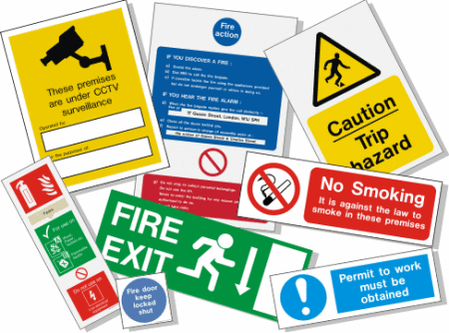

**Walton Towers Residents’ Association**

To: All residents

From: Chair of Residents Association

Date: 05/04/2020

Re: Lockdown rules

Dear committee members,

Since the implementation by the government of the national emergency quarantine order a week ago, many residents are ***in a quandary*** as to how this translates to communal living. As such, it has been decided that we need to meet and ***thrash out*** a of set of rules that we can ***abide by*** as a community.

Some people have ***expressed concern*** at the unnecessary use of lifts in the buildings and would like to declare them out-of-bounds except for those that live on the 3rd floor or above, excluding residents who are disabled or are above the age of retirement. Others have expressed concern over the use of common areas, such as the main ground floor patio or roof area for ***working out*** by some residents. There has also been some concern at the walking of dogs within these same communal spaces by elder residents and mention of the dumping of rubbish in communal bins instead of the proper rubbish receptacles in the street.

Clearly we need to establish to rules and boundaries. I would love to hear your ideas but we do need to ***address the question*** of communal areas for exercise and recreation. Some of us have also raised the idea of **morale-boosting activities**. So far, people have ***put forward*** a daily workout or dance class that can be given from the communal patio with participants taking part from their balconies. A drama workshop could be given in the same manner, plus language, cookery, or DIY classes which can be given via communal video conferencing platforms.

The meeting will take place next Monday on the usual platform.

Yours sincerely

Richard Grimes

Chair

1. The residents are confused by the rules about communal areas.

2. The residents’ association want to establish a stricter quarantine in the building.

3. Some residents would like to restrict the use of elevators.

4. Some residents have been doing their jobs in communal areas.

5. Some residents have been throwing trash in the communal areas.

6. Some residents want advice about health.

7. Some residents have suggested different workshops to keep everybody happy.

Indicate whether the statements below are true or false.

True□ False□

True□ False□

True□ False□

True□ False□

True□ False□

True□ False□

True□ False□

